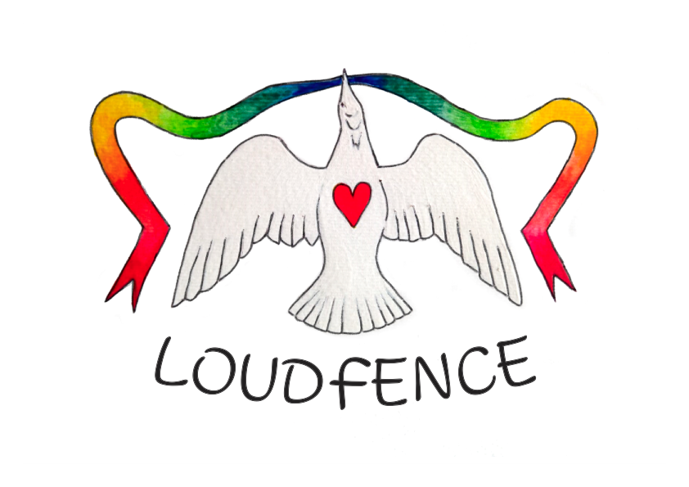
LOUDfence – make your voice and your compassion visible

LOUDfence Charter

LOUDfence is a tool to enable and empower faith communities to begin the difficult task of addressing the damage caused by abuse perpetrated by anyone in faith based settings. Christian communities who can talk openly and honestly in a constructive and non-adversarial manner can challenge stigma and offer support to those who have been injured by abuse. This is not just crucial for the welfare of survivors but also for the faith community as they cannot repair the damage done by abuse without the help and input of survivors.

In order to facilitate this process LOUDfence have produced this Charter so that all participants know exactly what values a LOUDfence must promote and objectives it must pursue.

LOUDfence must be non-adversarial, collaborative and co-produced in a spirit of honesty, openness and a desire for true repentance, genuine change and if possible, healing and reconciliation.

LOUDfences which are endorsed by us and which are included on our digital LOUDfence map must be driven by the values of compassion, justice, truth, openness, solidarity and be a celebration of those who have the courage to speak out. The LOUDfence must enable connection between those who have been harmed by abuse and their faith community and it must challenge divisive and destructive myths (i.e speaking out about abuse is being disloyal to your faith community and faith leaders are the enemy). A LOUDfence will never seek to tear down but always to seek to aid healing, repair and reconstruction.

Clergy and members of faith communities must undertake never to minimize and dismiss abuse. Survivors do not want risk management strategists or reputation managers; they need faith leaders, priests and fellow believers who are there to offer emotional and spiritual support and do all they can to facilitate contact between the survivor and their church, if the survivor feels able.

LOUDfence.com

