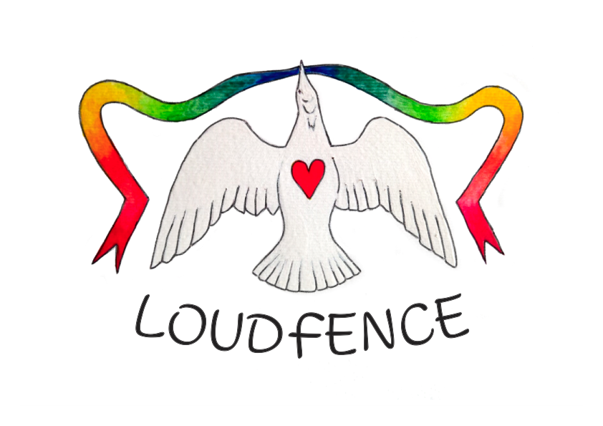

LOUDfence
Preparatory Pack

LOUDfence
Preparatory Information

Child Sexual Abuse is an international, multi-denominational problem, which at it's core is an abuse of power. Where there are people there will be some who will seek to exploit a power differential. These abuses combined with the instinct to conceal the problem in order to preserve institutional authority, has the opposite of it's intended effect. Faith leaders who attempt to conceal abuse cause even greater scandal, which in many cases has led to many people globally, no longer observing their faith in a way which brings them into contact with institutional churches. Religious organisations which respond in this manner are engaging in a self-defeating exercise.

LOUDfence gives survivors, practising and non-practising Christians, churchless Christians and so many others a voice and opportunity to actively participate in changing the culture of the institutional church. A church which actively celebrates the bravery of survivors in coming out and values them as critically important assets is far less likely to foster a default instinct to protect abusers or condone abuse enablement. It will foster a pro-active safeguarding attitude amongst everyone in the church instead of
Safeguarding/Survivor Support Ministry being the province of a select specialist few who exist as a "necessary evil" at the peripheries of the church. This in turn sends a message to those who miss church and have reluctantly stepped away from the practice of their faith. It provides an opportunity for the repair of trust and the beginning of dialogue which enables those who have been harmed and many others to feel able to return to the practice of their faith. To feel able to access church is especially critical in a sacramental church.

LOUDfence empowers parishioners and enables them to be part of the solution by giving them an avenue to express their feelings on what was a previously forbidden subject. The same reasons are true for spiritual, adult and other types of abuse in the church; and child abuse in other contexts. LOUDfence can be adapted to address institutional abuse in schools, community groups, residential homes and other settings as well as a community response to child abuse in families. LOUDfence can be a community activity of solidarity and support with abuse survivors. It can happen at a church, school, municipal building or any community space where civic leaders and members of the public can gather to demonstrate their feelings and views about abuse and their concern and support for survivors.

On a suitable date, all are invited to tie ribbons to a fence (or similar structure) or tree as a sign of solidarity, care, hope and to act as a memorial for all that has been lost by abuse. Some may also wish to tie labels or messages of support. Organisers may laminate and add their own messages, explanations and facts about abuse. Survivors should be supported to join if they wish, or just to come and witness the strength of support for their experiences and suffering. Communities may wish to organise other activities to coincide with LOUDfence; for example, highlighting sources of support, an act of repentance, a public information campaign, workshops on prevention and support for victims, an act of worship such as a survivors’ mass right through to a trauma-informed recovery activity for survivors (like meditation). LOUDfence enables a community to celebrate what they want to be - compassionate, transparent and truthful.

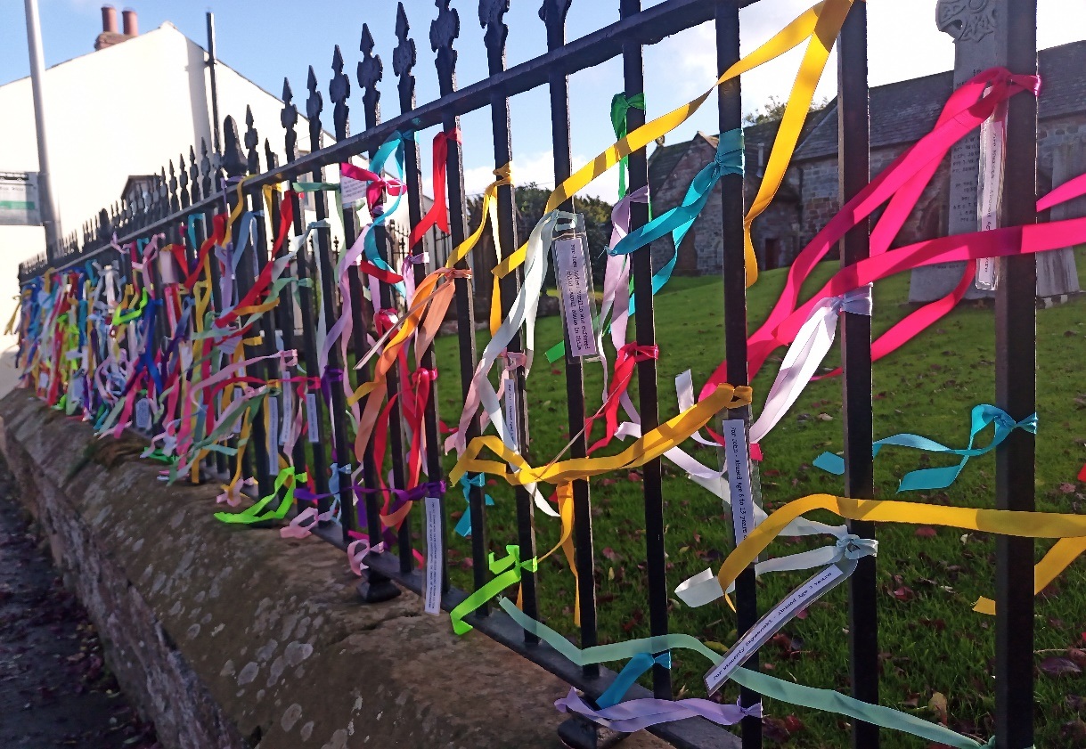

Practical suggestions and tips from the experience of running the first UK LOUDfence in Cumbria and subsequent LOUDfences across the UK.

Lead Up to LOUDfence
The key ingredient for a successful LOUDfence is publicity. A LOUDfence is only as effective as the amount of people who see it, know what it is for and feel empowered to participate. Contact local newspapers, radio and television stations. LOUDfence is an incredibly news worthy subject – they will be interested. Post articles on your parish website and social media pages with an email address. Many larger churches and cathedrals have set up a LOUDfence digital ribbon request page on their website so those who cannot attend the LOUDfence in person can still participate in the LOUDfence by requesting a ribbon and/or message is placed on the LOUDfence for them. Churches have informed us they have received messages from Washington and West Virginia, Poland, Italy, Australia, New Zealand, Spain, France, California and Germany, as well as from all parts of the United Kingdom. Allowing people from much further afield to contribute means that survivors will be affirmed by the level of support and also allows the church to foster the identity of being one global church community. Allowing those who wish to contribute from further afield also means that the LOUDfence benefits survivors from other parts of the church who live in other countries. The reach and influence of a LOUDfence frequently radiates much further than it’s parish boundaries.

Place notices in parish magazines and on notice boards with an email address. Make announcements after services and involve all members of the parish, who wish to participate.

Be curious about those who don’t want to be involved; treat is as an opportunity to ask why they feel this way. Changing the culture of the church will be done one heart at a time.

On the Day
On the day there are certain practical suggestions which we found helpful.

1) Basket of ribbons.

2) Paper tags and pens for those who wish to write messages.

3) Perhaps most importantly of all, a sympathetic ear and a compassionate heart. It is important to remember LOUDfence is a celebration of survivors courage and the empowerment and inclusion of the entire parish. It is our experience that LOUDfence is an opportunity for healing, understanding and the beginning of dialogue. It is a visible signal of support to those who have been wounded, marginalised and excluded. It challenges common myths such as "those who report abuse are the enemies of the church" or "those who stop attending church use the abuse crisis as an excuse to do so or were never really that committed to their faith in the first place".

People with work/school commitments which meant they weren’t available to tie on their own ribbons, delivered tags and ribbons to me or left them at the church beforehand and asked if I would tie them on to the LOUDfence. One little boy called Danny, knocked on my door to tell me he would be back late as he had a music lesson after school, so asked me to tie his message tag onto the LOUDfence for him. A photo of his tag is below. It reads “Just because I am nine does not mean I am not allowed to be safe.” This tag is a message to us from the future of the church. It tells us he has considered the fact that he cannot take for granted he is safe in church.

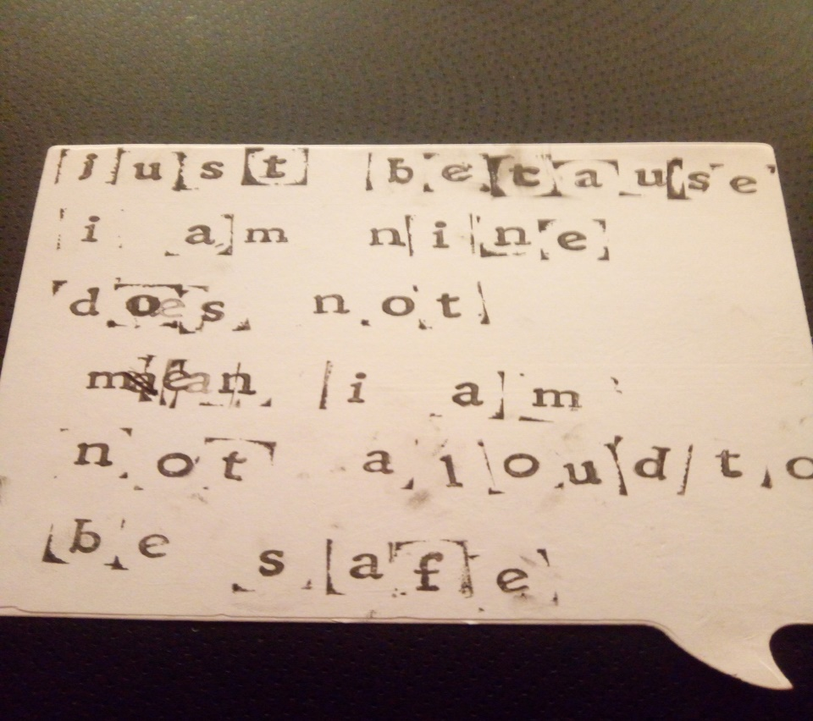

Our mission is firstly, to work with survivors of abuse to offer emotional and spiritual support and challenge the stigma and silence which prolongs and exacerbates the trauma.

Secondly, the harm perpetrated against victims in the church attacks this group as principal victims but radiates outwards to the entire church. There are three other groups within the church who are damaged by the abuse

A) Laity who stop attending church. This group of Christians feel powerless to tackle the abuse crisis. They think they have no agency in the church and are faced with the false choice of accepting the way things are now or to stop attending church. LOUDfence gives a voice and agency to this group.

B) Laity who continue attending church but harbour deep anxieties about the abuse crisis but do not say anything because they are fearful they will be labelled as disloyal or trouble makers. This group of christians remain fearful, are not inclined to trust and erect barriers around themselves in church in order to "self protect". This group remain physically in church but are emotionally absent. LOUDfence gives a voice to this group and helps to dismantle those emotional barriers by providing opportunity for open supported discussion at parish level.

C) Clergy The clergy, a vast majority of whom are innocent, do not feel they have agency to address the abuse crisis. Many priests have told us they absolutely accept they are not the principal victims but feel as if they live under a constant cloud of suspicion. Many of them are told not to attempt to support victims for fear they will make matters worse. This is a desperately misguided instruction to give the clergy and creates the false impression they do not care. LOUDfence gives a voice to this group and helps to remove the gag which binds the mouth of those clergy who wish to offer pastoral support and care for the wounded body of christ - survivors. This is also instrumental in removing the "us and them" barriers within the church which leads to clericalism and clergy/laity segregation.

LOUDfence enables the beginning of a process of culture change within the church. The need to enact culture change is a recommendation made by IICSA in it’s final report concerning both the Church of England and Roman Catholic Church. Churches which talk together, stay together. We do this by celebrating what we want to be. We do this by celebrating the virtue of protecting others by speaking out about our safeguarding concerns. We do this by supporting survivors and doing all we can to enable them to flourish with their wounds. We do this by actively seeking to turn safeguarding into an act or primary evangelisation by example. Healing the church will be the work of our lifetime and the job of every person in the church. Our work starts now.

Antonia Sobocki
Director
LOUDfence UK

